Activity 4.3: A presentation on the history of computing
Use the text and images on pages 2–12 of this worksheet to design a four-slide presentation for your classmates on one aspect of the history of computing. The presentation should take no longer than two minutes to deliver next lesson.
Aspects of the history of computing that you could focus on include:
- mechanical computing devices
- important people in the history of computing
- the internet and the World Wide Web
- the future of computing.
Or you could come up with a theme of your own.
You do not need to include all of the text and images provided. You can select whatever you think is most relevant and interesting. You can also edit the content and may even carry out your own research to add to it.
Use the grid below to complete stage 1 of the design cycle: understand the task (ask yourself questions about the purpose of your document and its intended audience).

Purpose | What does the presentation need to do? What information does it need to give to the person reading it and how should the information be presented to make it accessible to the audience?
Audience | Who is the presentation for? What will the intended audience find attractive and enticing?
Then move on to stage 2 of the design cycle: develop your ideas and plan a solution.
And, when you have planned your report, move on to stage 3 of the design cycle: follow your plan to create your solution.
Remember to save your work regularly.

Introduction
In simple terms, a computer is any person or device that carries out mathematical calculations.
People have been inventing devices to help them to compute numbers for hundreds of years. Early computing devices were mechanical, and it is only very recently that we have come to associate the word computer with the electronic devices that we use today.
The science of computing which underpins computer science has developed over time. This document contains some of the milestones and the people that were responsible for them that make up the history of computing.
Abacus
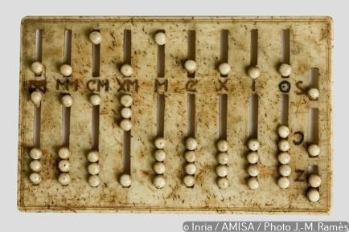
The abacus in the picture is a Roman abacus ivory and dates to the second to fifth century CE.
An abacus is also called a counting frame because it is usually made from rods supporting beads that are held together inside a frame. The abacus is used to carry out mathematical calculations with great speed and accuracy and dates back to a time before the Arabic numeral system that we use today was adopted.
The exact origin of the abacus is unknown, but the abacus is still in use today for computation in Japan and other parts of the Far East. Practiced abacus users can complete calculations with phenomenal speed and can even beat an electronic calculator.
The IAMAA (International Abacus and Mental Arithmetic Alliance) was started in 1983. Its mission is to promote school student achievement and prepare for global competitiveness by fostering the best education and ensuring equal access. It holds an international abacus competition every year.
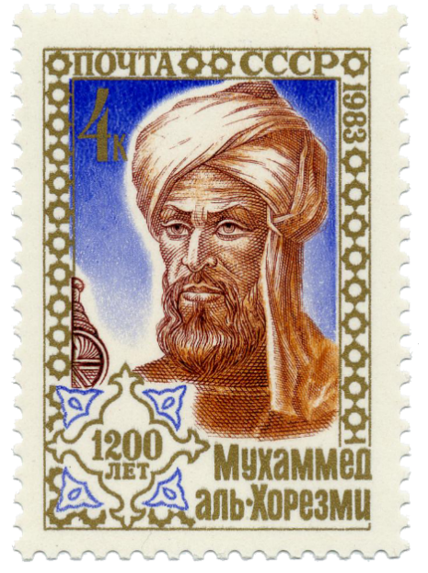
al-Khwarizmi (780–850 CE)

A stamp bearing the image of al-Khwarizmi
Known as the ‘father of algebra’, al-Khwarizmi was an outstanding Persian mathematician and one of the first Directors of the House of Wisdom in Baghdad in the early ninth century.
He oversaw the translation of important Greek and Indian books about mathematics and astronomy into Arabic.
The word ‘algorithm’ is derived from his name.

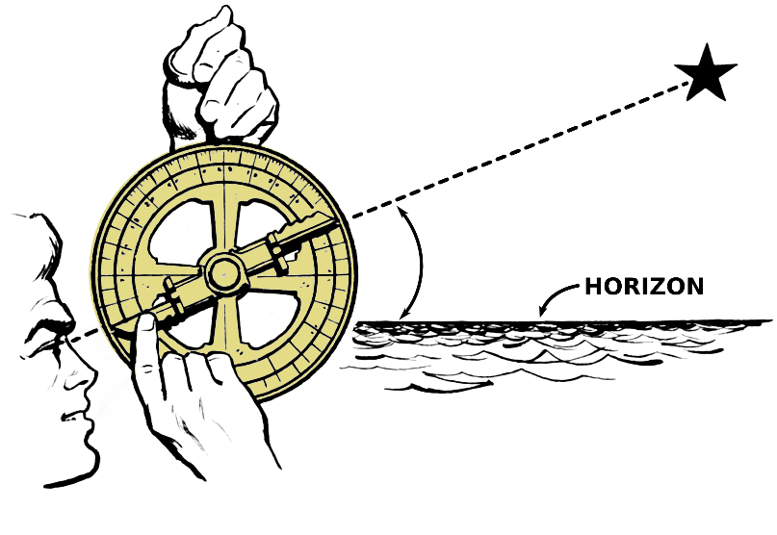
Astrolabe
The astrolabe was an early astronomical instrument that was used by sailors to help them navigate until it was replaced by the sextant in the eighteenth century. The device was made of brass with scales inscribed on rotating discs and is, in fact, an analogue calculator. The geared mechanical astrolabe was invented by Abi Bakr of Isfahan in 1221.

Slide rule
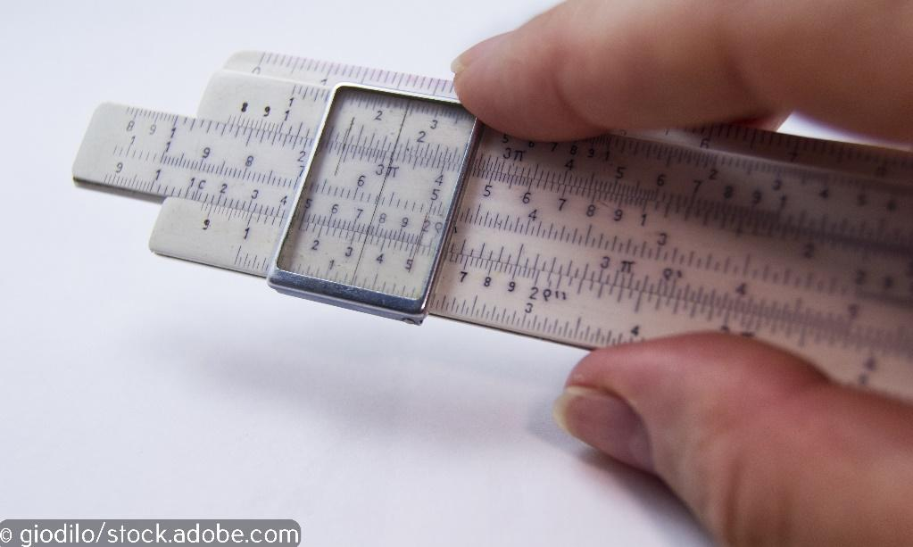
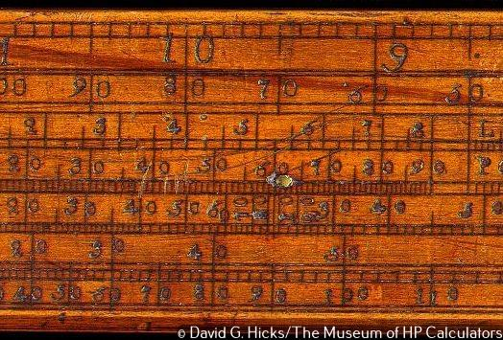
The photograph shows a section of a very old wooden slide rule, dating back to 1632. This manual, mechanical device was commonly used in schools before the invention of an affordable electronic calculator in the 1970s. By sliding analogue scales against each other, mathematical calculations can be carried out quite quickly and with accuracy.
Charles Babbage and the Analytical Engine
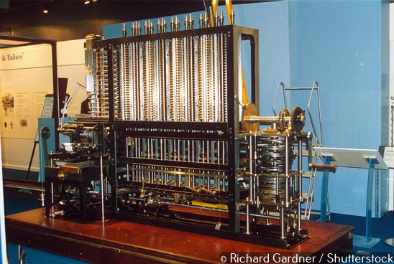
Charles Babbage, known as ‘the father of computers’, designed the first computer capable of doing complex calculations. It is totally mechanical and has no electrical parts. Known as the Analytical Engine, it was designed to evaluate mathematical formulae and to have higher powers of analysis than Babbage’s original Difference Engine of the 1820s. It was so complex and required so many precise moving parts that only part of the machine was built before Babbage’s death in 1871.
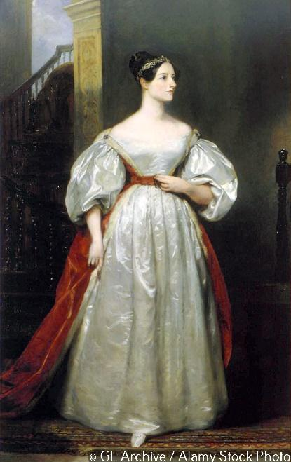
Ada Lovelace (1815–1852)
Augusta Ada King, Countess of Lovelace, known more simply as Ada Lovelace, was a mathematician and writer. Ada first met fellow British mathematician Charles Babbage in June 1833, while she was a teenager. He recognised her mathematical ability, and this led to a long working relationship between the two.
She was particularly interested in Babbage’s work on the Analytical Engine and is best known in the field of computer science for publishing the first computer program.

Alan Turing (1912–1954)
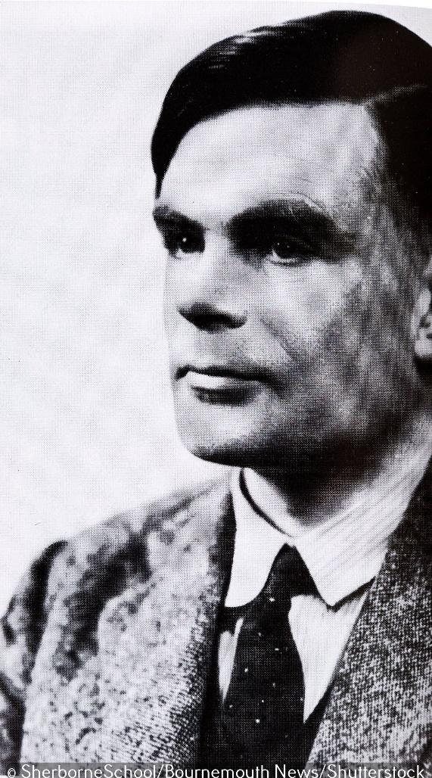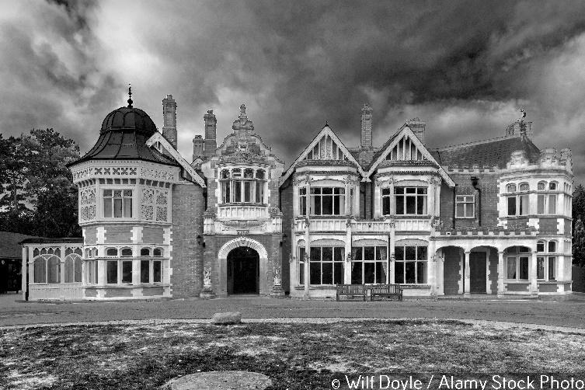
Alan Turing Bletchley Park
In 1936, mathematician, Alan Turing, wrote a mathematics paper, ‘On Computable Numbers, with an Application to the Entscheidungs problem’, which came to be seen as a theoretical basis for today’s computers. In his paper, Turing imagined a single machine that could compute any problem, effectively uniting all human or problem-specific ‘computers’ into one universal device.
When Turing was invited to Bletchley Park during the Second World War to join a team of code breakers put together to crack Nazi military codes, he got a chance to put some of his theories into practice. Working with Flowers and Newman, they built Colossus, the first model of a general-purpose computer. After the war, Turing went on to build the Pilot ACE, one of Britain’s earliest stored program computers and the oldest complete general-purpose electronic computer in Britain.
By the mid-1950s, the computers imagined by Turing started to be built in real life and were becoming common in large institutions, companies and university departments. Such early machines, like the Pilot ACE and EDVAC were so enormous that they filled large rooms and they required a team of people to operate them.
Alan Turing is now celebrated as the inventor of the modern electronic computer and is considered to be the single most important figure in the history of computing.
Colossus
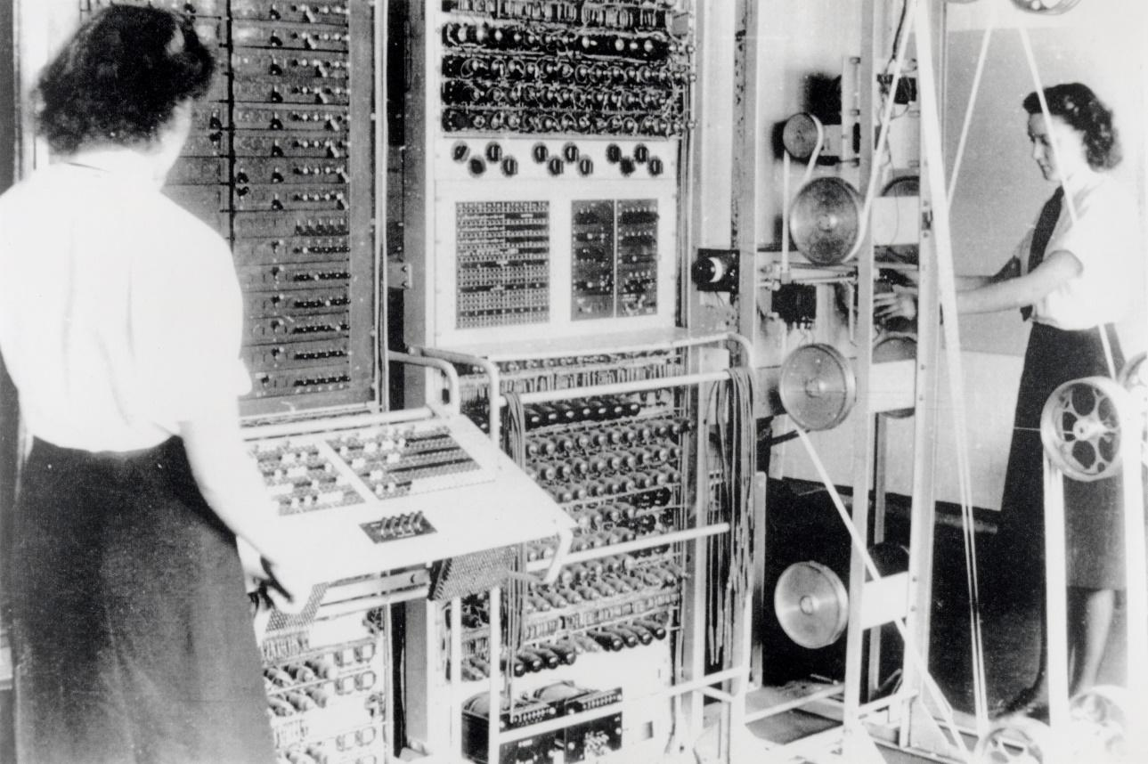
A Colossus Mark 2 codebreaking computer being operated by Dorothy Du Boisson (left) and Elsie Booker (right), 1943
Alan Turing formalised the concepts of algorithm and computation to produce the first model of a general-purpose computer.
Tommy Flowers and Max Newman built Colossus at Bletchley Park between 1943 and 1944 to break the German Enigma codes. Colossus was the first programmable electronic digital computer and was used extremely effectively to enable the Allies to obtain a vast amount of high-level military intelligence from intercepted Nazi radio signals during the Second World War. It is estimated that the work of the code breakers at Bletchley Park shortened the war by two years and saved millions of lives.
Transistors
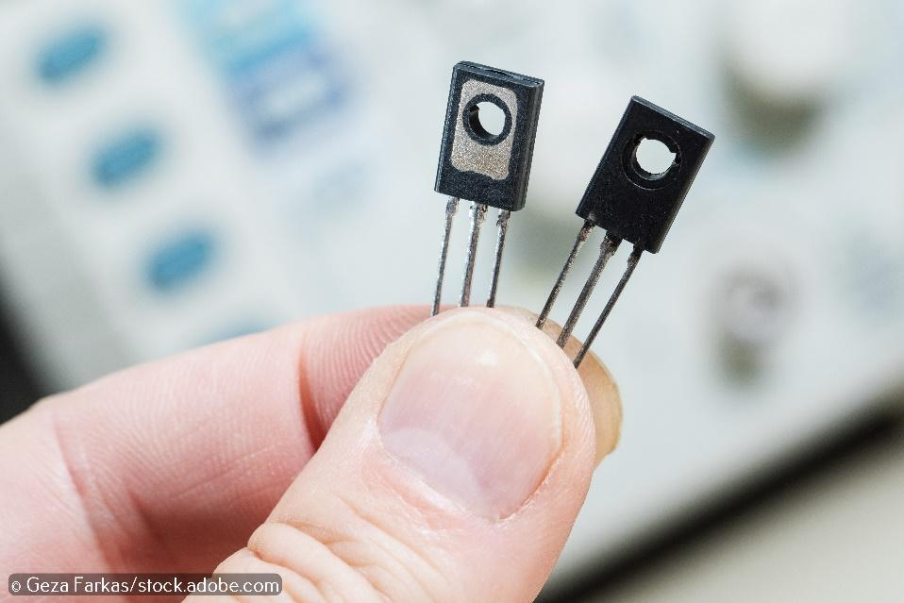
The first big reduction in in the size of electronic computers came when the large valves which acted as the gates to process data were replaced by much smaller transistors. The transistor, invented by Bardeen, Brattain and Shockley in the late 1940s, paved the way for much cheaper and more compact computers.
Transistors are small electronic component that acts like a switch. They are used to build the gates that process data inside a computer. The more transistors there are, the faster the data can be processed. Computers in the early 1970s had thousands of transistors. Today’s computers have billons of transistors but, due to miniaturisation, their central processing units (CPUs) are more or less the same size as the chips in computers of the early 1970s.
It was big news in 2016 when a team at Lawrence Berkeley National Laboratory successfully built a functional 1-nanometer-long transistor gate, which the lab claimed was the smallest working transistor ever made.
von Neumann and EDVAC
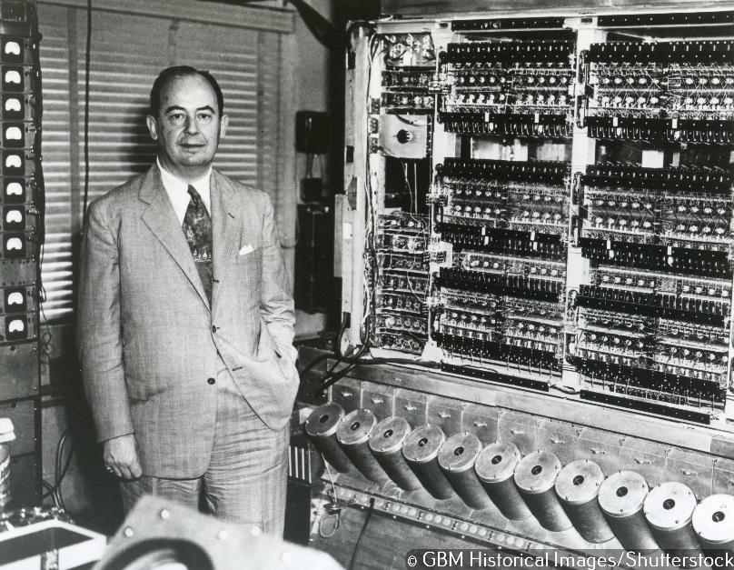
von Neumann and EDVAC, built in 1949
John von Neumann was the inventor of the first stored program computer. It was based on a design that commonly became known as the ‘von Neumann architecture’. The early computers that von Neumann built, such as EDVAC, were enormous and filled entire rooms. They were also extremely expensive to build and needed a team of people to maintain them. As a result, they were only found in government departments, universities and very large companies.
Microchip (1959)
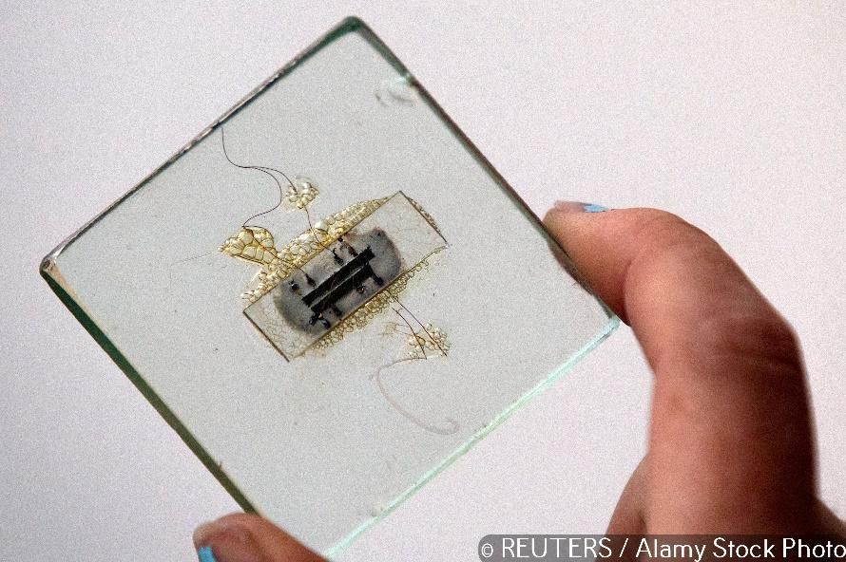
An early microchip
The next big reduction in the size of the computer came in 1959 when, working separately, Jack Kilby and Robert Noyce both invented the microchip. The key to the invention was Kilby’s inspired idea of creating all of the component parts of a transistor on a single chip of silicon. When Kilby and Noyce were able to prove that this concept worked, the invention (for which they are jointly credited) opened the door for the silicon chip industry that produces the processing units which form the basis of all of our digital devices.
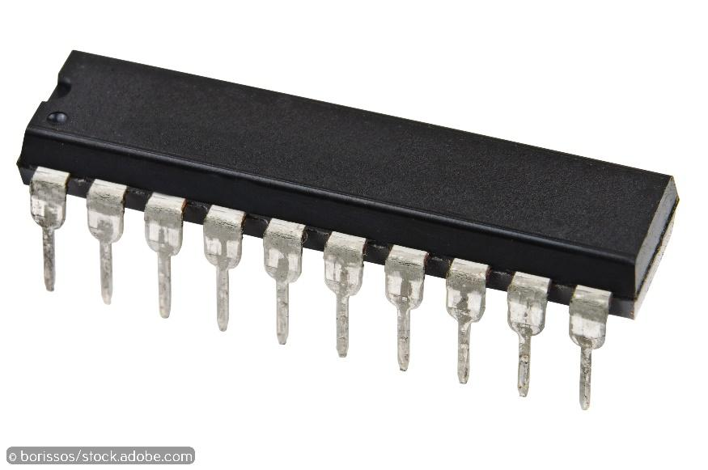
The invention of the microchip was probably one of the most important inventions ever made and it launched a new information age. Modern microchips are now made in their billions.
Electronic calculator
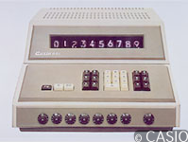
In September 1965, Casio released the 001, the world’s first electronic calculator with a memory function. At a cost of the equivalent of £2,000 today, this was the first portable electronic calculator.
Rapid development and a rapidly growing market meant that, by the late 1970s, the smaller ‘pocket’ calculator was much more affordable, and they began to replace log tables and slide rules for computation in schools and the world of work.
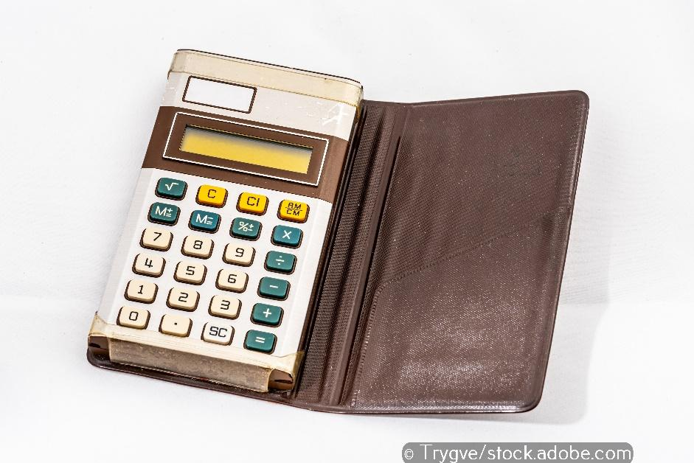
IBM PC
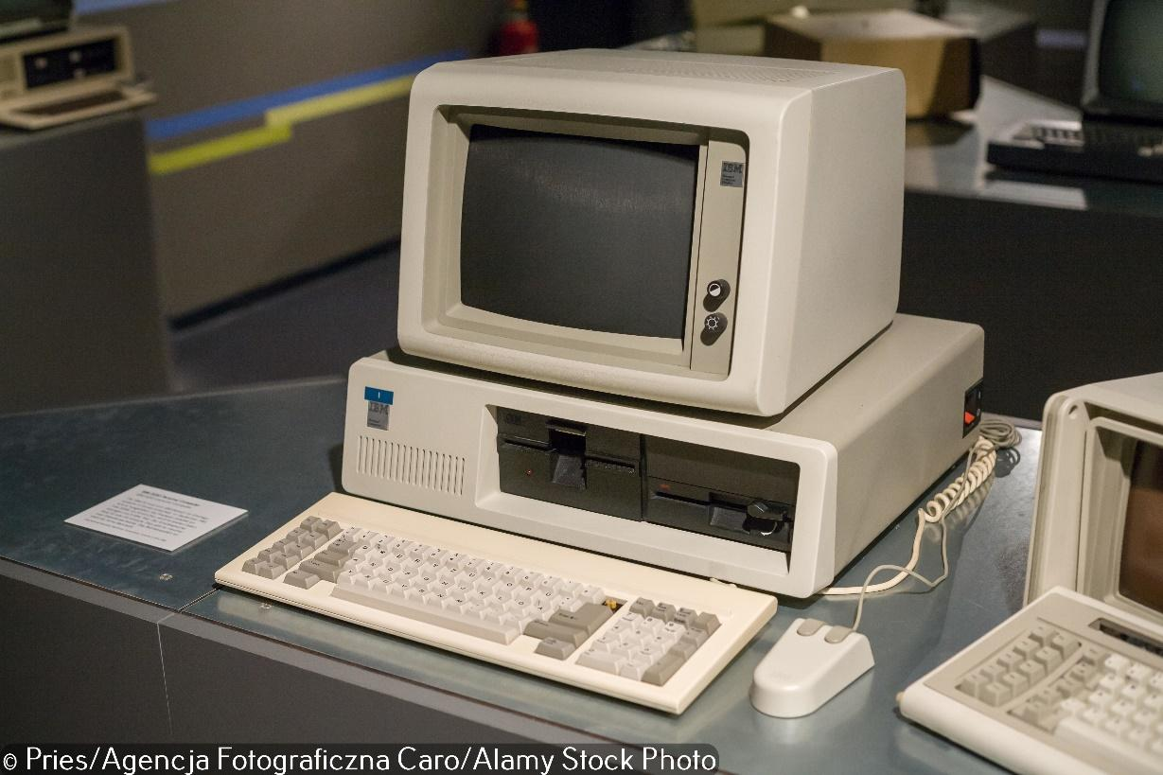
By 1981, computer circuit boards were small enough to build small computers for use by individuals in homes and offices. They were called ‘personal computers’ because they were designed to be operated by a single user rather than a team of operators.
The first IBM PC, formally known as the IBM Model 5150, was based on the Intel 8088 microprocessor and used Microsoft´s MS-DOS operating system. MS-DOS was a command line non-graphical operating system that required the user to type text commands to make the computer function. You may have seen people in films from the 1980s using non-graphical operating systems.
The IBM PC revolutionised business computing, gaining widespread adoption by industry. The IBM PC was widely copied and led to the creation of a vast ecosystem of software, peripherals and other commodities for use with the platform.
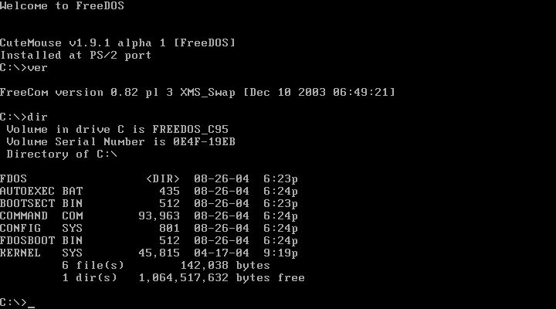
MS-DOS command line operating system
The internet and the World Wide Web
The first workable prototype of the Internet came in the late 1960s with the creation of ARPANET, the Advanced Research Projects Agency Network. Originally funded by the US Department of Defence, ARPANET used packet switching to allow multiple computers to communicate on a single network. The modern, global network of computers that we now call the internet was ‘born’ on 1 January 1983 when the ARPANET adopted TCP/IP. From there, researchers began to assemble the ‘network of networks’ that became the modern internet.

Following the adoption of TCP/IP by ARAPNET to create the internet, the online world took on a more recognisable form in 1990, when computer scientist Tim Berners-Lee invented the World Wide Web. While it’s often confused with the internet itself, the web is actually just the most common means of accessing data online in the form of websites and hyperlinks. One way to think about it is the internet is the hardware that stores and carries the data (the servers, wires, storage memory etc.) and the World Wide Web is all the data and information that is carried by the internet.
Tim Berners-Lee
In 1980, physicist Tim Berners-Lee, a contractor at CERN, proposed and prototyped ENQUIRE, a system for CERN researchers to use and share documents. In 1989, Berners-Lee wrote a memo proposing an internet-based hypertext system. Berners-Lee specified HTML and wrote the browser and server software in late 1990

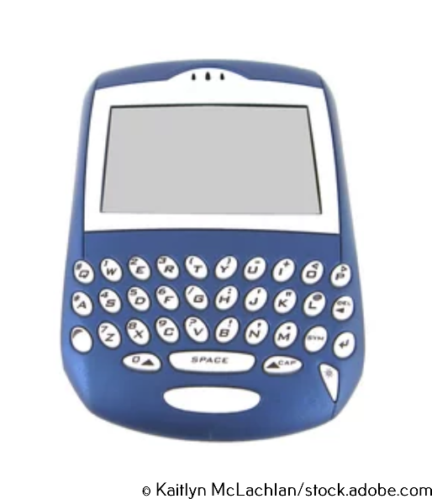
Smartphones
There were no touchscreens on the early smartphones of the early 2000s and they were principally used as mobile phones, so the screens were relatively small. As the screen was not a touchscreen, the devices came with a keyboard to make them interactive.
Then the first iPhone, the first smartphone with a touchscreen, was launched. It removed the need for a keyboard and paved the way for modern smartphones and tablet computers.

Artificial intelligence and machine learning
Artificial Intelligence, or AI, is the branch of computer science that stems from the understanding that the computers of the future are likely to have such enormous processing power that they will be able to perform tasks normally requiring human intelligence.

Quantum computing
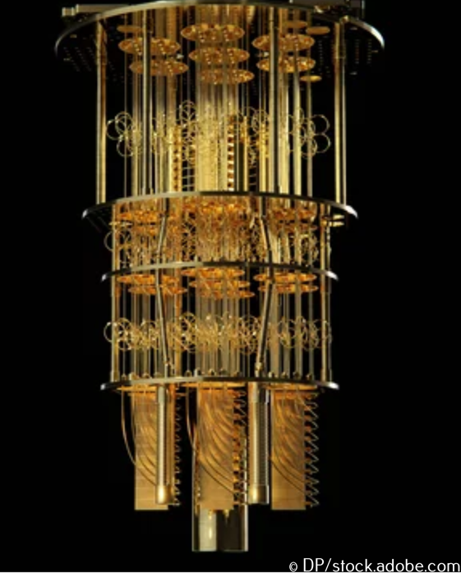
Computer scientists are investigating completely new methods of computation, such as quantum computing. The computer shown uses the spin property of electrons so that individual electrons are processing and storing data. This means that a single atom can store many pieces of data, opening the door for infinite parallel processing.

